UNIT 2 — MOTION IN TWO DIMENSIONS · TEACHER KEY  Vectors Quiz, Version B | U02 / S2.2  QUIZ · ANSWER KEY

1.
Restate 310° in two other ways.

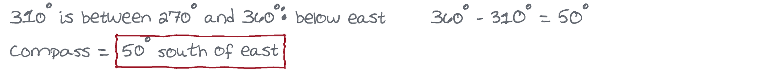
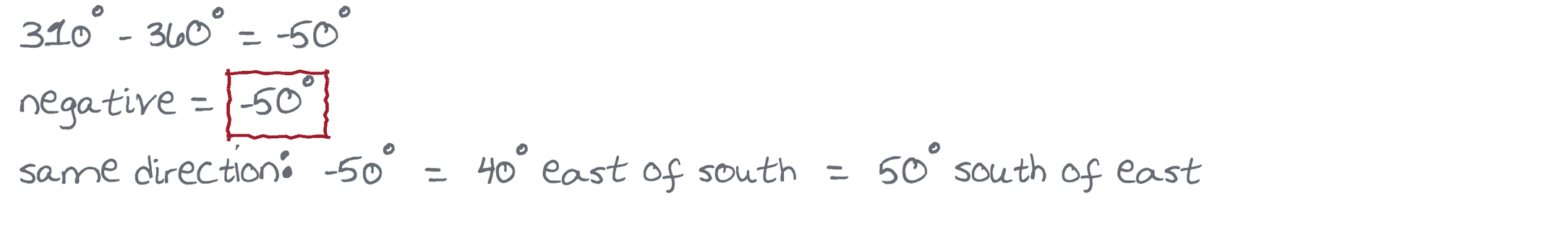

2.
Restate 25° south of west in two other ways.

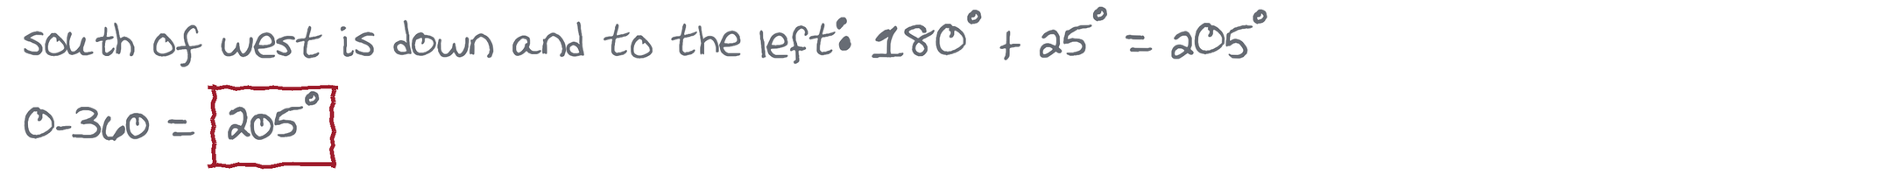
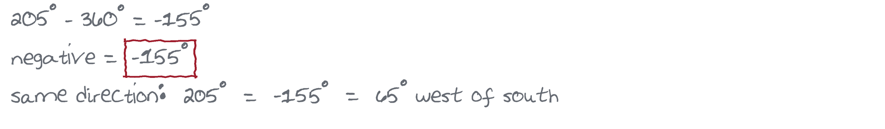

3.
Restate −200° in two other ways.

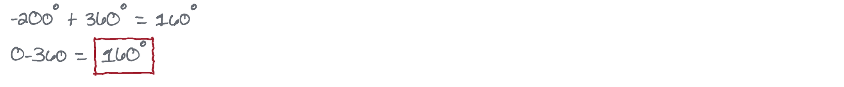
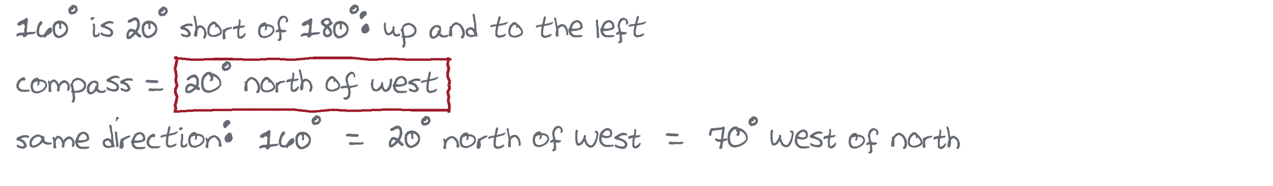

4.
Rey's speeder moves east at 52 m/s while a crosswind pushes it south at 36 m/s. Find the speeder's resultant velocity: magnitude and direction.

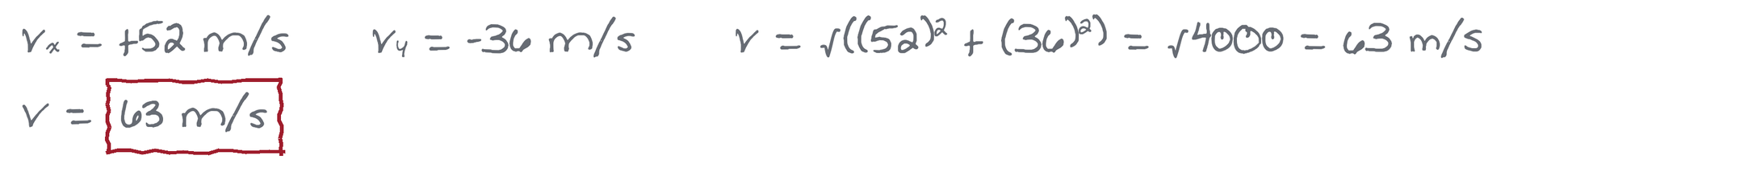
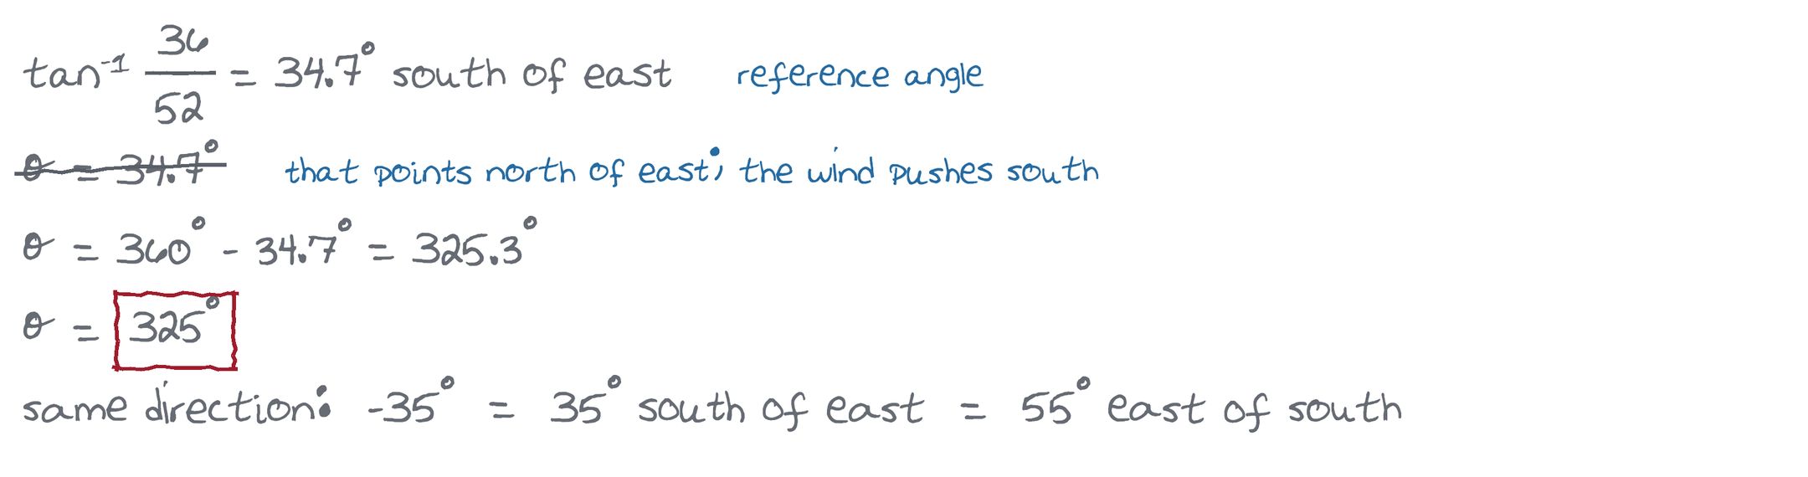

5.
Dumbo flaps at 24 m/s toward 25° north of west while a gust blowing toward 40° east of north adds 9.0 m/s. Find Dumbo's resultant velocity: magnitude and direction.



